Problem 5. function in igraph

a. add_edges{igraph}: Add edges to a graph

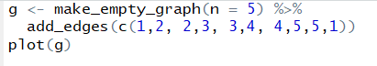

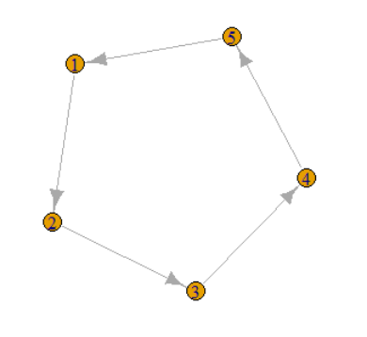

b. add_vertices {igraph}: Add vertices to a graph

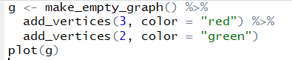

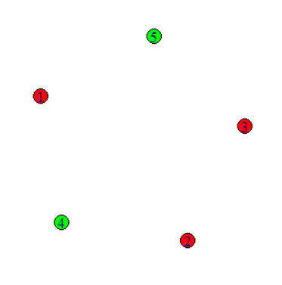

c. set_edge_attr {igraph} : Set edge attributes

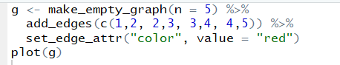

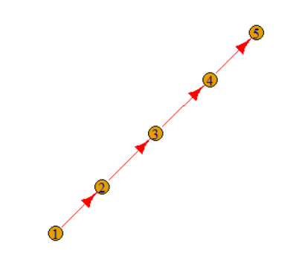

d. make_ring {igraph}: Create a ring graph



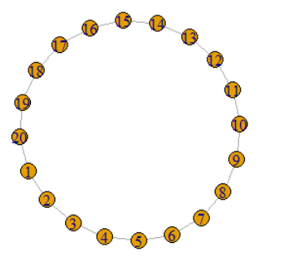

e. subgraph {igraph}: Generate subgraph of a graph

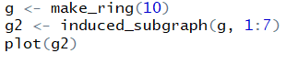

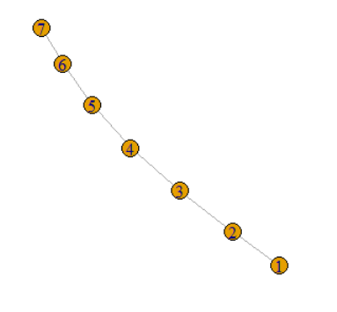

f. girth {igraph}: Get the girth of a graph



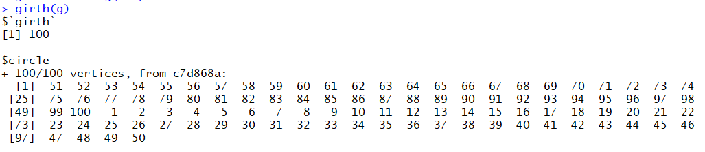

g. delete_edges {igraph}: Delete edges from a graph

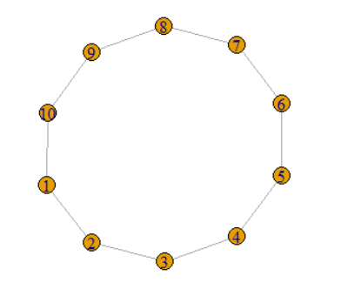

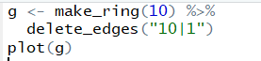

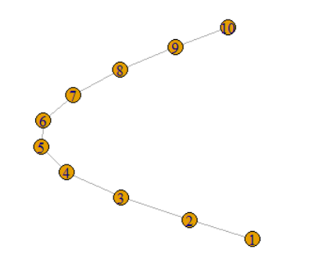

h. make_tree {igraph}: Create tree graphs



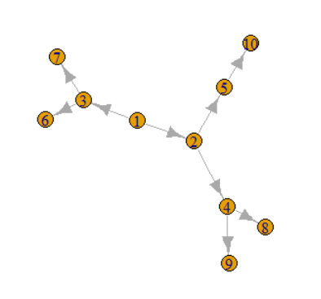

i. layout_as_tree {igraph} : The Reingold-Tilford graph layout algorithm



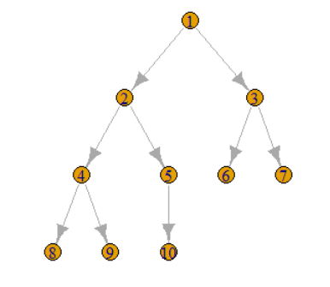

j. sample_pa {igraph}: Generate scale-free graphs according to the Barabasi-Albert model



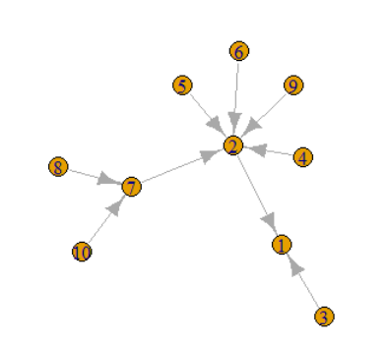

k. degree {igraph}: Degree and degree distribution of the vertices



l. distance_table {igraph}: Shortest (directed or undirected) paths between vertices

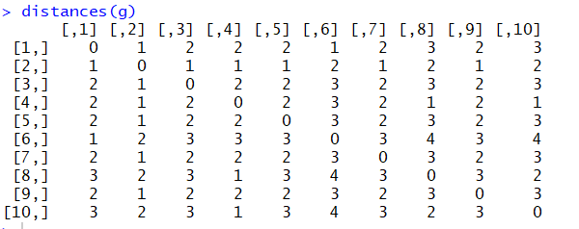

m. sample_gnp {igraph}: Generate random graphs according to the G(n,p) Erdos-Renyi model



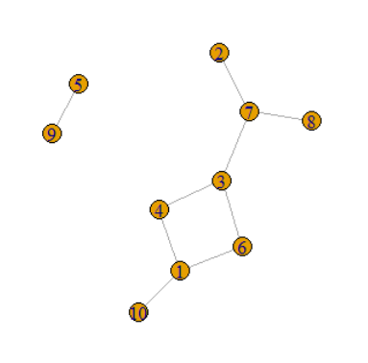

n. as_adjacency_matrix {igraph}: Convert a graph to an adjacency matrix



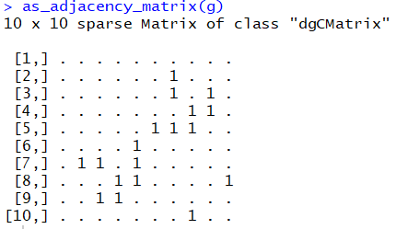

o. gorder {igraph}: Order (number of vertices) of a graph

